Moodle as teaching support in the Health Classroom

EDGCT5008 – Leonie ‘Tilly’ Waite (30120209)

Objective
When faced with the decision what to choose as my negotiated task I knew straight away that I wanted to do something with the Moodle platform we use at Wodonga TAFE. When it comes to Moodle, for the past few years I have felt like a Parkinson’s patient frozen at the point where carpet goes over into linoleum, wanting to step forward but unable to move. This negotiated task assessment was my push in the back, making me step over this invisible barrier, create a unit on Moodle and learn and discover how it can support not only the students but also myself as the teacher (and learner).
I felt that to be able to not only give it my heart and soul but also ensure it would be a genuine learning activity for me, I had to choose a subject that I love and know quite well. Then at least the task would indeed focus on how to use the knowledge I have to create better learning opportunities and activities for students instead of focussing on actual content. Having been a physiotherapist for over 20 years it had to be related to that.
As such I decided to develop supporting and interactive learning resources and activities to assist students to better grasp the theory and practical components associated with specialised physiotherapy units to enable them to become highly skilled and knowledgeable physiotherapy assistants.

Background information
For the past three years I have been delivering a cluster of units associated with the Physiotherapy Stream for Allied Health Assistance students. This cluster consists of three units of competence out of the Health Training Package and is associated with the Certificate IV in Allied Health Assistance. This qualification prepares students to work side-by-side with an allied health professional and with a physiotherapist in particular when they have successfully completed this cluster.
The three units have overlapping elements hence the clustering. Elements have both a large theoretical components as well as practical aspects; it is imperative that the student has a good understanding of the theory to be able to master the practical parts such as objective testing. Clinical skills were traditionally taught in a hospital based setting with ‘real patients’ but are now more and more taught in a simulated environment. The latter option often requires expenses resources and lacking these resources over the past three years I had to make do with scenarios, role play and minimal equipment.
As there were no supporting resources available when I first started to deliver these units I have developed my own resource, in the form of a very informative workbook, containing both the theoretical background as well as information about associated practical components. As delivery only takes place over a total of 18 hours, students are required to do a fair amount of self-directed learning using the workbook. This is quite difficult when it comes to practical, hands-on skills. My main focus has been on refining this resource, including more pictures, photos and diagrams, better descriptions, and revision questions.
Although I have had requests from teachers from other TAFEs in regards to purchasing this workbook, I feel this resource assists those students whose intelligence is mainly linguistic and/or intrapersonal, but does little for students with a dominance of the other intelligences. I also feel that students have some idea in regards to the practical testing components but do not feel competent and confident enough to apply it in a real life situation. As such I would like to make some changes.

Proposal
The proposal for the negotiated task contained multiple facets, from supporting learning theories and literature to the way the curriculum should be developed and delivered and the role of the Moodle platform. I saw all the information gained over the past few weeks and during the forum in Ballarat in relation to Gardner’s Multiple Intelligences, Flow Theory, learning and teaching on-line, multi-media and even the Padagogy Wheel as pieces of a puzzle. Over time and with a lot of reflection these pieces seemed to come together and the link they all had to each other became clear. If I could just use this new found knowledge and understanding and apply it to my Moodle development.
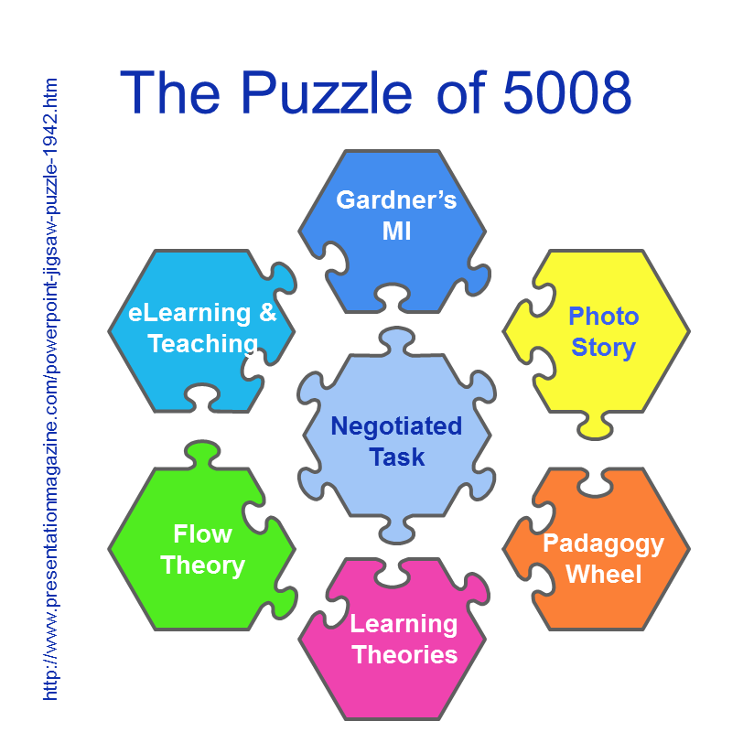

Literature
Using the Moodle platform as a support to the delivery of the physiotherapy units was the first thing that came to mind when thinking about the negotiated task and seemed like a good idea, but initially I was unable to provide the reasoning behind that ‘good idea’. My argument had always been that these units were predominantly hands-on and should be taught in a face-to-face environment and the only way to use Moodle was to ‘dump’ theory on it. This all changed when I started to learn more about Howard Gardner’s Multiple Intelligences and Bloom’s Taxonomy and it made me realise that my workbook, even though not a bad resource, was mainly accommodating students with linguistic and/or intrapersonal intelligence. Although all students probably would have acquired some new skills, knowledge, and/or attitudes (SKA, Blooms three domains of learning) at the end of the 18 hours delivery, learning predominantly took place in the lower order (remembering, understanding, applying) and students with dominance in other intelligences as described by Gardner may have had to work twice as hard to understand the subject matter using non-preferred intelligence(s).
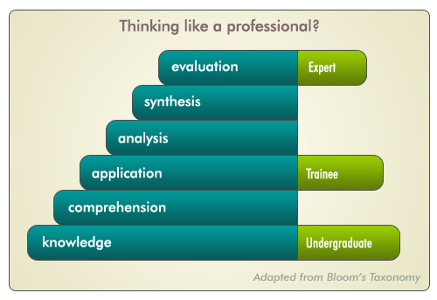
Keeping the ‘end result’ in mind and thinking about what attributes I like to see in students deemed competent in the Physiotherapy Assistance specialisation I like them to be life-long learners, independent lateral thinkers, and learn from experience and start thinking like a professional. For the theory part it would follow Bloom’s Taxonomy of Objectives in the Cognitive Domain and means students need to have a deeper understanding of the content, apply that knowledge and in the end synthesis and evaluate what they have learned.
However, as said before, my delivery will entail teaching clinical skills as well. “Clinical skills refer to those clinical examination and procedural skills commonly performed in real or simulated clinical environments” (London Deanery). For clinical skills development, such as the ability to accurately perform objective tests, development of Bloom’s psychomotor domain needs to occur, where students progress form imitation to naturalisation.
www.faculty.londondeanery.ac.uk
Using the Moodle platform in combination with the traditional face-to-face delivery would classify the new delivery as ‘blended’. Although this can extend the range of resources available for students and allowing more flexibility in the delivery, in their book Littlejohn & Pegler (2007, p. 34) state that “where use of new media is optional or incidental, students will typically not value material presented in that way as much as material that is clearly core or assessed”. As such I need to consider the impact of the content placed on the Moodle platform, ensure there is a link between what has been discussed in class and what is available on-line as well as utilise resources available in Moodle in the assessment tasks.
As stated during the Flow Theory workshop, we need to utilise innovative practices to ensure continuous student engagement. This is also confirmed by Ellaway and Masters (2008) who “highlight that e-learning is not just about the content and the delivery of teaching, but is a pedagogical approach that aims to be flexible, engaging and learner-centred: one that encourages interaction, collaboration and communication (as quoted in London Deanery, e-learning in clinical teaching).

Learning Theories
One aspect mentioned during the Flow Theory workshop was ‘incremental learning’ through clarity of learning outcomes. This linked in well when asking myself if the Moodle resource was there “to support learners through providing content using e-learning” or if my intention is to “use e-learning as supporting the learning process” (London Deanery, e-learning in clinical teaching). To be able to answer this question I first need to ask myself what learning theory forms the background for this way of delivery?
Although I have mentioned that the sequential learning of skills is part of the Cognitive Domain of Bloom’s Taxonomy, I feel that both a Humanistic as well as a Constructivism approach, combined with multimedia learning theory, play a role in the way I will deliver this cluster:
- Humanism – this is a form of self-directed, adaptive learning where knowledge, meaning and finally skill is created through the application of both intra – and interpersonal intelligences. Intrinsic rewards, the student wants to gain more skill and knowledge, play a role in this higher order learning and the role of the educator is that of facilitator.
- Constructivism – my delivery will take place in an adult learning environment. Adults come with more or less life and work experiences. In a constructive learning environment learning is an active process with existing knowledge from past experiences being combined with new information creating fresh ideas or concepts.
- (Cognitive theory of) Multi-Media Learning – where the focus is on effective use of a student’s auditory and visual channels for information processing.

Delivery
Delivery will still take place over 6 sessions, which each session consisting of three hours class time. Changes will be made to the session plans to incorporate a mixture of theory and practical during all sessions and students will be introduced to Moodle. Explanation will be provided on the role of Moodle – as a supportive tool in their journey to become a physiotherapy assistant and master clinical skills with a good theoretical grounding. To ensure students utilise this supportive resource certain tasks will refer to information provided on Moodle.
This delivery will be a work in progress and through student evaluations at the end of the delivery I hope to establish the strengths and weakness of this blended delivery, what worked well and where I need to make adjustments.

Assessments
Instead of having one set of assessment tasks for all students, certain assessment tasks will now have different options so that students can choose the assessment task that best suits their mode of learning. One assessment task I would like to include is one discussed during 5007 – the reversed/flipped classroom, where students teach each other. I first introduced this during the latter part of semester two with high school students and I was amazed of the results.

Resources
Although the main focus is still on the face-to-face delivery and the use of the workbook, I started to feel more and more excited about the prospect of using Moodle. But where to begin, what to include, how to set it up? Thoughts of power-points with voice over, YouTube clips to explain theory aspects, and videos providing an opportunity for students to see the objective tests as often as they would like where some of the possibilities that crossed my mind. Doing the e-learning module as well as reading about utilising online resources when teaching clinical skills I repeatedly came across the same points to remember when setting up content on Moodle:
- Although e-learning has become part of mainstream education, we still need to ask ourselves what the main reason is for setting up a unit on Moodle. This reason “must be concerned with meeting learners’ needs and facilitating the educational process, not simply seizing on technological innovations” (London Deanery. e-learning in clinical teaching)
- Utilise the World Wide Web for information and YouTube clips before you attempt to reinvent the wheel
- Keep an eye on quality assurance and only recommend those sites that are appropriate. Students could be involved in providing feedback about the suggested sites.
- If you as a teacher do not feel competent enough to set up a unit on Moodle enlist help. Otherwise give it a try as it doesn’t require a master’s degree to start on Moodle.
- Ensure students have the knowledge and capabilities to utilise the e-learning resource
- When requiring students to interact with each other on-line provide facilitation as well as feedback.

Setting up the cluster on Moodle – a Reflection
A full reflection of this negotiated task is not possible at this stage as although I have started the development of the unit on Moodle and am yet to use it in class. So this reflection concentrates mainly on this first stage - setting up the unit on Moodle.
I read somewhere that when it comes to Moodle you “just have to do it” and the rest will follow. That may be so, but some backup information on where to start and how to the basic things would have been helpful. Wodonga TAFE does not provide hard copy resources to assist with creating Moodle as learning and teaching medium. Their argument is that by the time they have printed one off, it is out of date due to the constant updates. Mr Google was very helpful directing me to the Moodle website which provided the required advice I needed to start. The main aspects I wanted to focus on in my Moodle unit were:
- To create a nice flow of information
- Information that is clear and easy accessible
- Links to website which provide current and educational information
- Not to provided information overload and as such to set clear expectations for the student so they know what to do with the information on offer
- To establish resources for many of the multiple intelligences and not just the linguistic one. Through the use of YouTube clips I have been able to provide short visual/auditory information which is used to back-up the hands-on (kinaesthetic) component in class. With music being my last personal preferred intelligence I was happy to discover a clip that explained balance testing through a song. If it wasn’t for the knowledge about Gardner’s Multiple Intelligences I would have never included it.
As most of the resources for the Moodle content came from YouTube I found trying to find the right YouTube clip and ensuring it was accurate, educational and appropriate was time consuming but also enjoyable and informative to do. The sense of achievement when the right clip was found and inserted was enough to continue on.

Review
This cluster is scheduled to be delivered again by the end of February and as such, this is all very timely. I plan to evaluate the changes I have made by providing the students with an evaluation form by the end of the delivery. This evaluation form will be specifically developed for this delivery as it will have specific questions related to the delivery, assessments and resources.
I will organise for specific teachers from Federation University and associated with EDGCT5008 to have access to the physiotherapy Moodle units when marking my work.

Documentation
Documentation of this process will take place in my e-Portfolio. This will also house new and old lesson plans, assessment tasks and the student learning program, which provides information about the assessment tasks and session plans.
I believe this negotiated task is the centre-piece fitting in nicely with my chosen modules:
- Day 1, Workshop 4 – Blended training for national industry
- Gardner’s MI Theory
- Introduction to Learning & teaching online
- Flow Theory – Application to learning

References
Learning Theories. Cognitive Theory of Multimedia Learning (Mayer). Retrieved February 16, 2014, from http://www.learning-theories.com/cognitive-theory-of-multimedia-learning-mayer.html
Littlejohn, A. & Pegler, C. (2007). Preparing for blended e-learning. New York, USA: Routledge
London Deanery “Faculty Development”. Setting learning objectives. Retrieved January 25, 2014, from http://www.faculty.londondeanery.ac.uk/e-learning/setting-learning-objectives
London Deanery “Faculty Development”. Teaching clinical skills. Retrieved January 25, 2014, from http://www.faculty.londondeanery.ac.uk/e-learning/teaching-clinical-skills
London Deanery “Faculty Development”. E-learning in clinical teaching. Retrieved January 25, 2014, from http://www.faculty.londondeanery.ac.uk/e-learning/e-elarning-in-clinical-teaching-1
Wikibooks. Learning Theories/Constructivist Theories. Retrieved February 15, 2014, from http://en.wikibooks.org/wiki/Learning_Theories/Constructivist_Theories
Wikibooks. Learning Theories/Adult Learning Theories. Retrieved February 15, 2014, from http://en.wikibooks.org/wiki/Learning_Theories/Adult_Learning_Theories

